Carmelo's POS system October 28,2015

1- mysql commands to create database and tables

create database POS2;

use POS2;

create table customers
(
customerid int unsigned not null auto_increment primary key,
name tinytext not null,
address tinytext not null,
city tinytext not null,
state tinytext,
zip char(10),
country char(20) not null,
last_update timestamp
);

create table orders
(
orderid int unsigned not null auto_increment primary key,
customerid int unsigned not null,
amount float(6,2),
date date not null,
order_status char(10),
last_update timestamp
);

create table products
(
product_upc char(13) not null primary key,
product_desc tinytext,
quantity integer,
price float(4,2) not null,
cost float(4,2) not null,
catid int unsigned,
available boolean,
product_notes longtext,
last_update timestamp
);

create table categories
(
catid int unsigned not null auto_increment primary key,
catname char(60) not null,
last_update timestamp
);

create table user (
username varchar(16) primary key,
passwd char(40) not null,
first tinytext,
last tinytext,
email varchar(100) not null,
last_update timestamp
);

create table order_items
(
orderid int unsigned not null,
product_upc char(13) not null,
item_price float(4,2) not null,
quantity tinyint unsigned not null,
primary key (orderid, product_upc)
);

2- mysql commands to populate some tables

USE POS2;

INSERT INTO products VALUES ('067232976X','Sams Teach Yourself PHP, MySQL and Apache All-in-One',10,34.99,20.00,1,TRUE,
'Using a straightforward, step-by-step approach, each lesson in this book builds on the previous ones, enabling you to learn the essentials of PHP scripting, MySQL databases, and the Apache web server from the ground up.','2015-10-23 15:00');
INSERT INTO products VALUES ('0672319241','PHP Developer Cookbook',10,49.99,29.99,1,TRUE,
'Provides a complete, solutions-oriented guide to the challenges most often faced by PHP developers\r\nWritten specifically for experienced Web developers, the book offers real-world solutions to real-world needs\r\n','2015-10-23 15:00');
INSERT INTO products VALUES ('12345678', 'Fresh Sicilian Pizza',5,9.99,6.99,2,TRUE,' Traditional Sicilian pizza is often thick crusted and rectangular, \r\n but also round and similar to the neapolitan pizza. \r\n It is often topped with onions, anchovies, tomatoes, herbs, and strong cheese such as Caciocavallo and Toma.','2015-10-24 16:00');
INSERT INTO products VALUES ('987654321', 'Sweet Italian Sausage', 20, 5.99, 3.99,2,TRUE, 'In the United States, Italian sausage of pork sausage seasoned with fennel, salt, pepper and white wine as the primary seasoning.','2015-10-15 15:00');

INSERT INTO categories VALUES (1,'Books','2015-10-24-15');
INSERT INTO categories VALUES (2,'Food','2015-10-24-15');
INSERT INTO categories VALUES (4,'Medical','2015-10-24-15');
INSERT INTO categories VALUES (5,'Electronics','2015-10-24-15');
INSERT INTO categories VALUES (6,'Outdoor','2015-10-24-15');
INSERT INTO categories VALUES (7,'Other','2015-10-24-15');

INSERT INTO user VALUES ('carmelo', sha1('carmelo'),'Carmelo','Lattuca',"lattuca@yahoo.com",'2015-10-24 17:00');

3- Screens

a-Login Screen

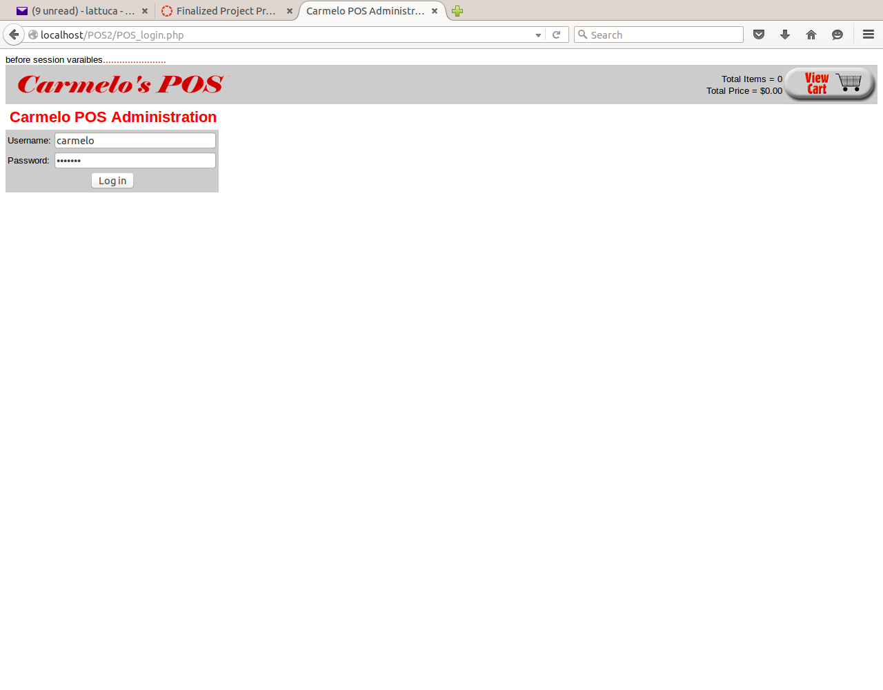

b- User Register Screen

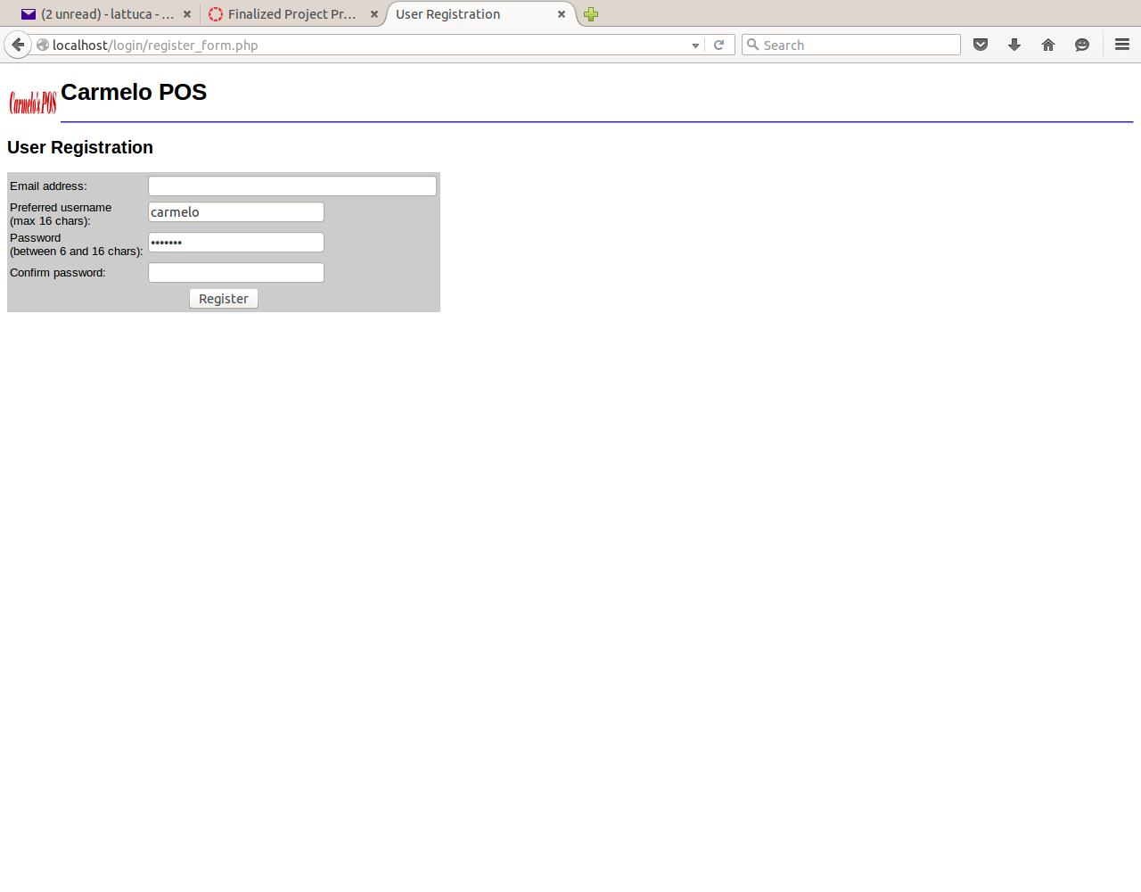

c- Admin Menu Screen

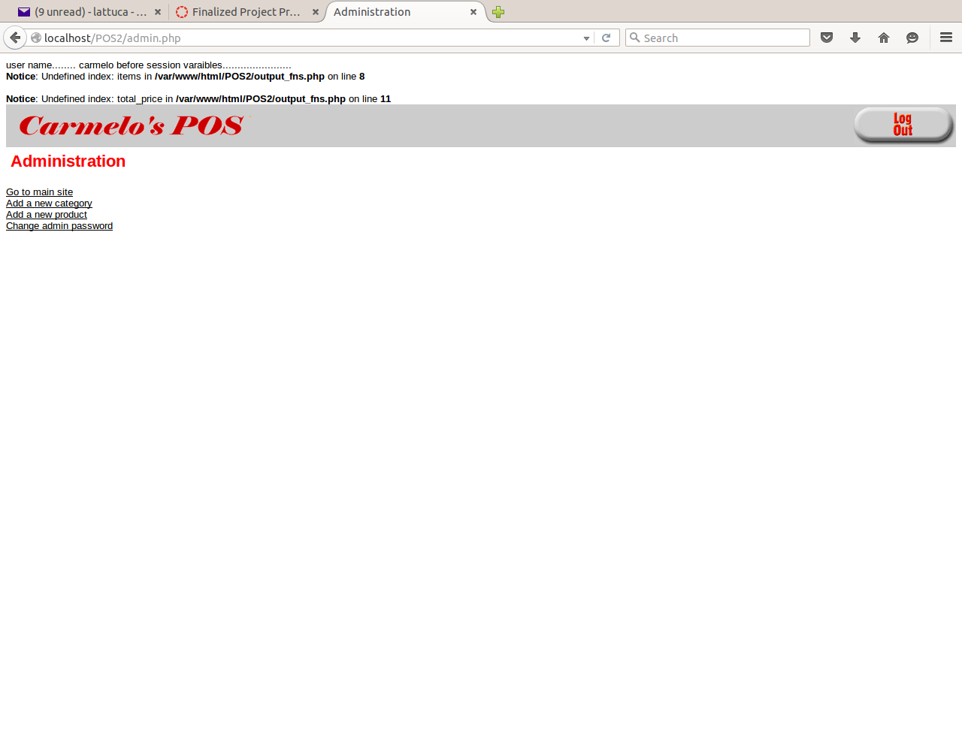

d-Add Category

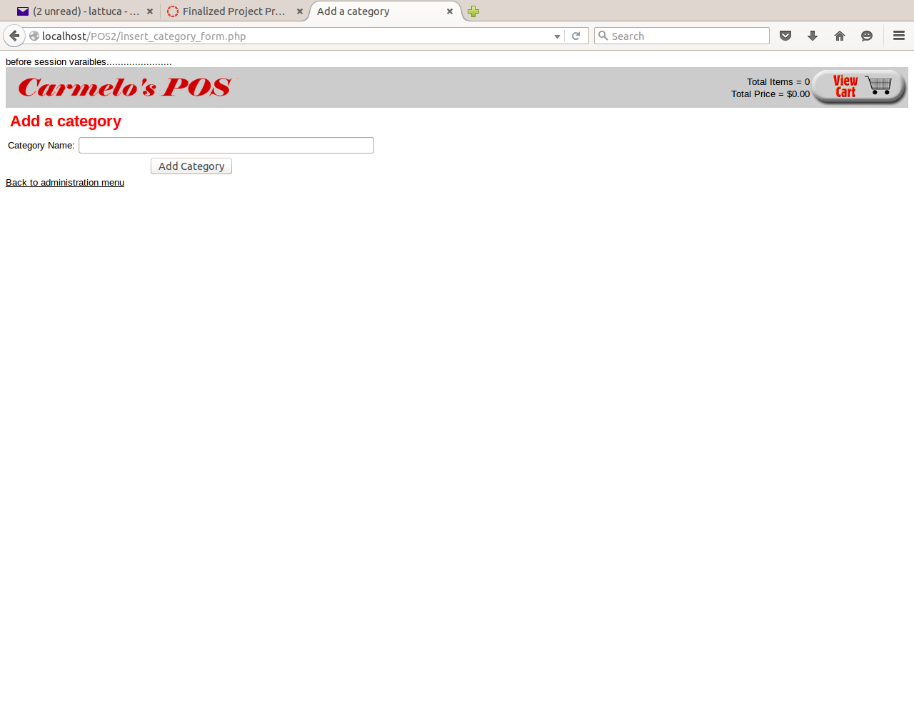

e- Add Product

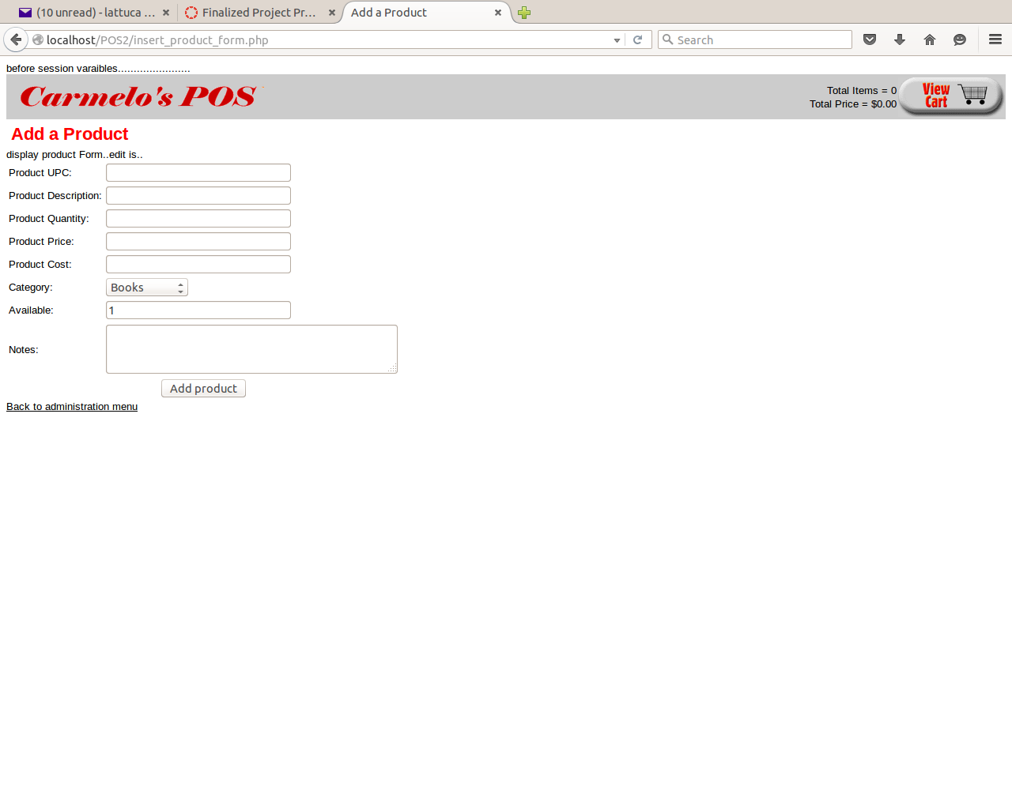

f-Change Password

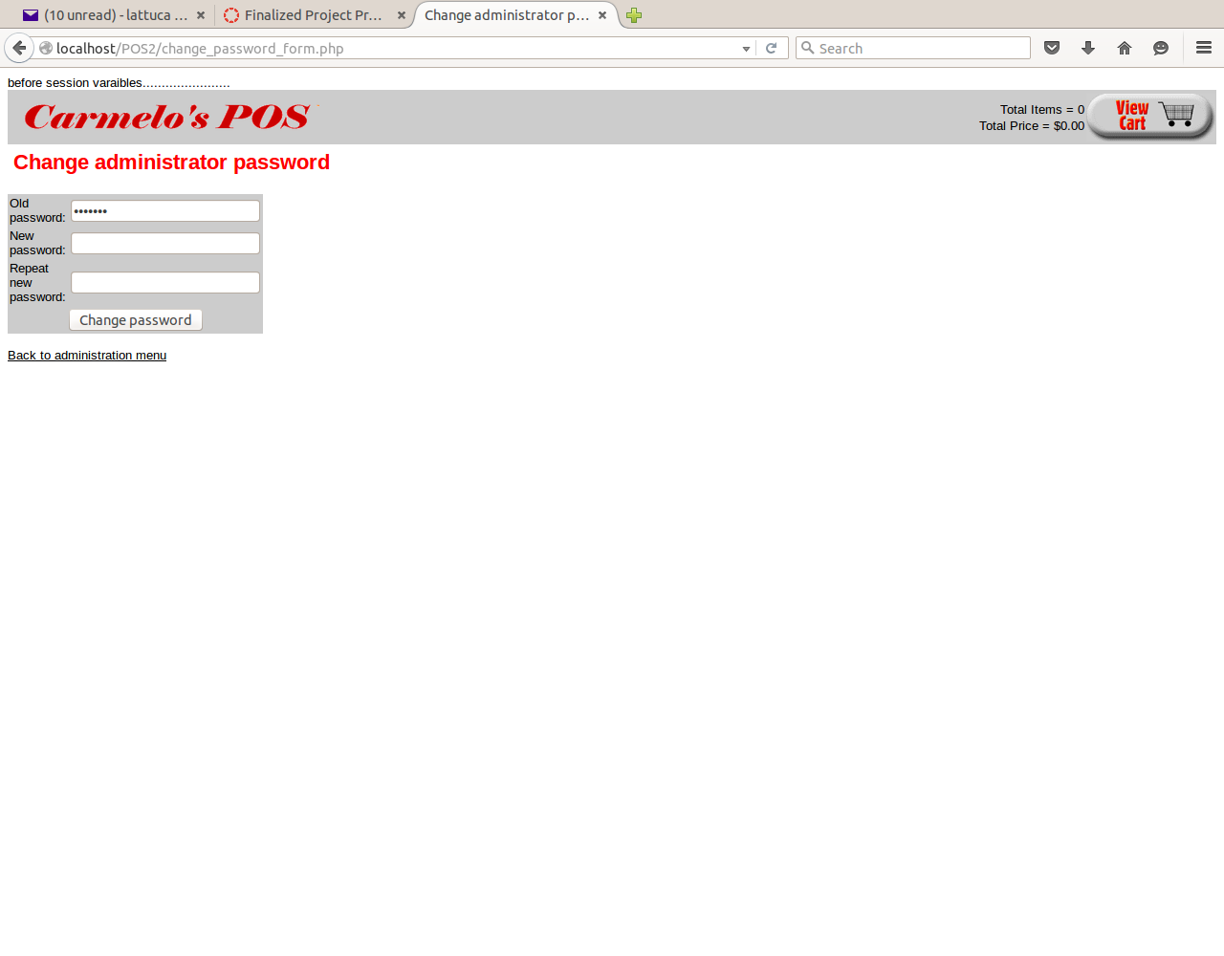

g- Shopping Menu Screen
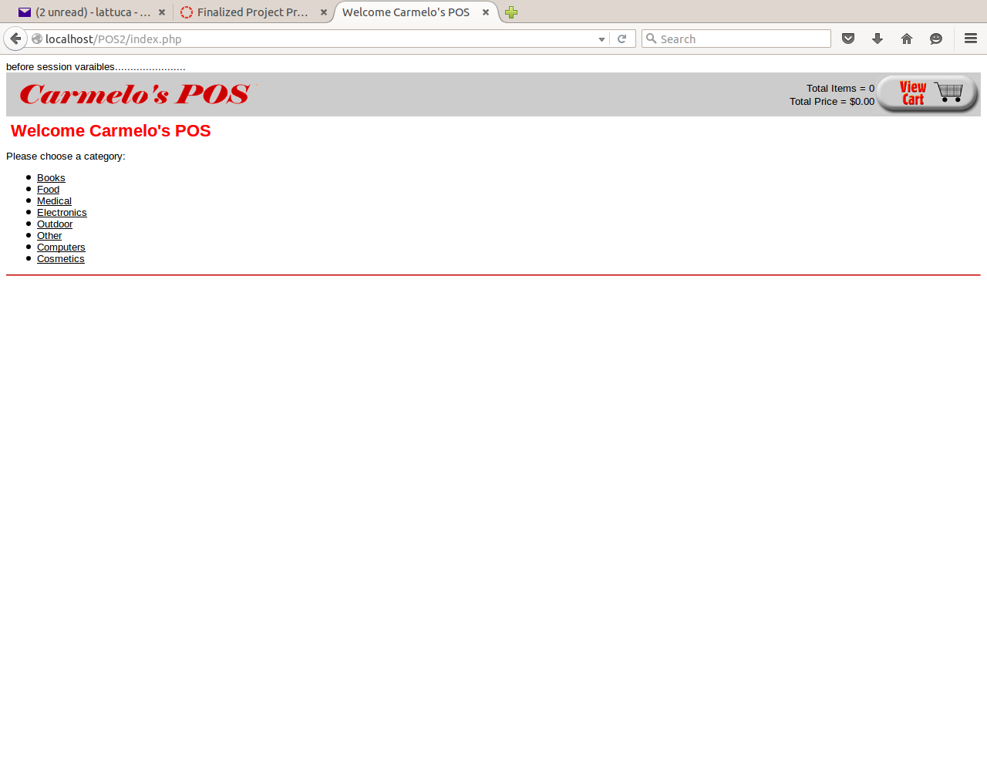

h- Select Product to Purchase

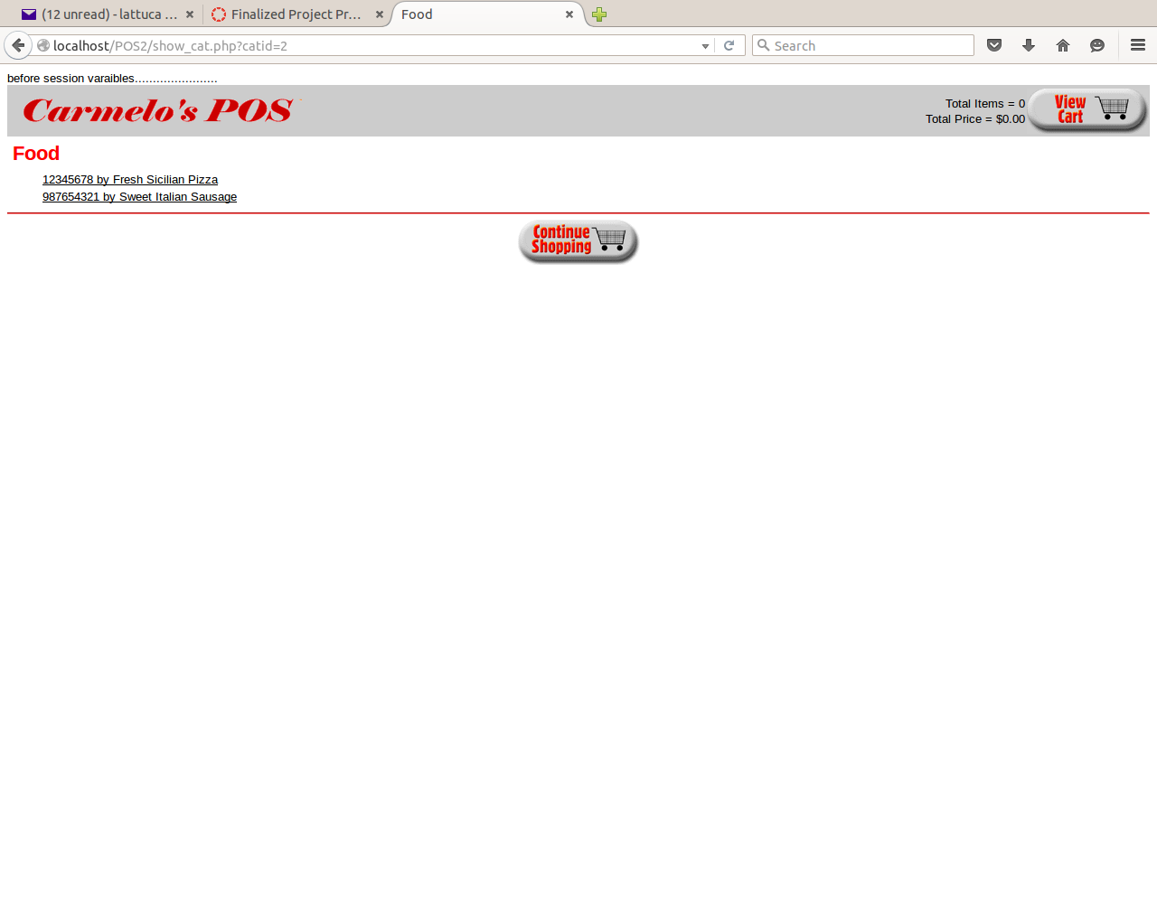

i- Product Selected

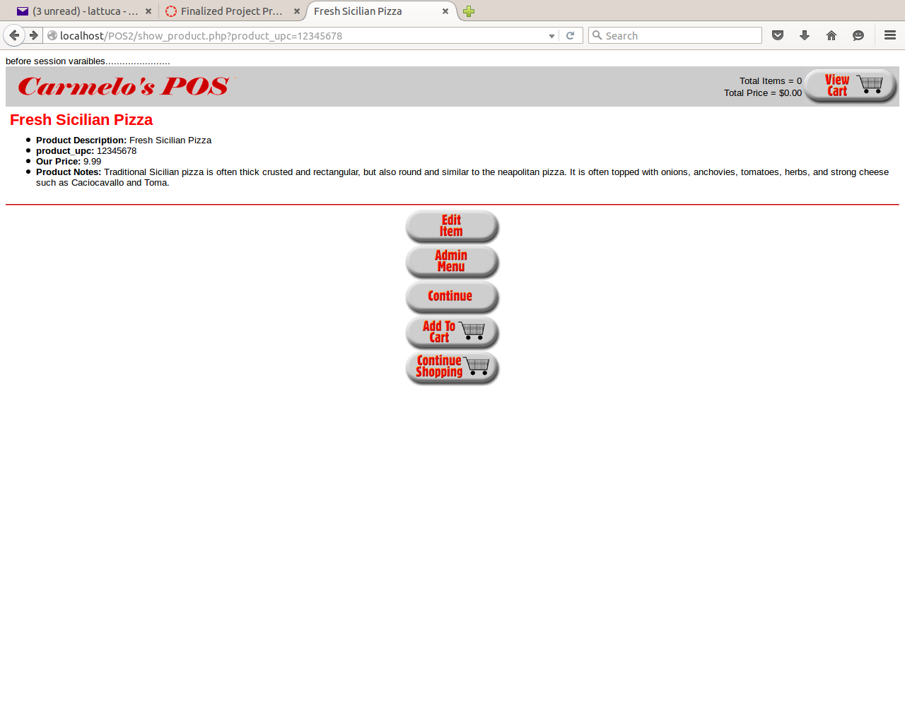

j- Shopping Cart

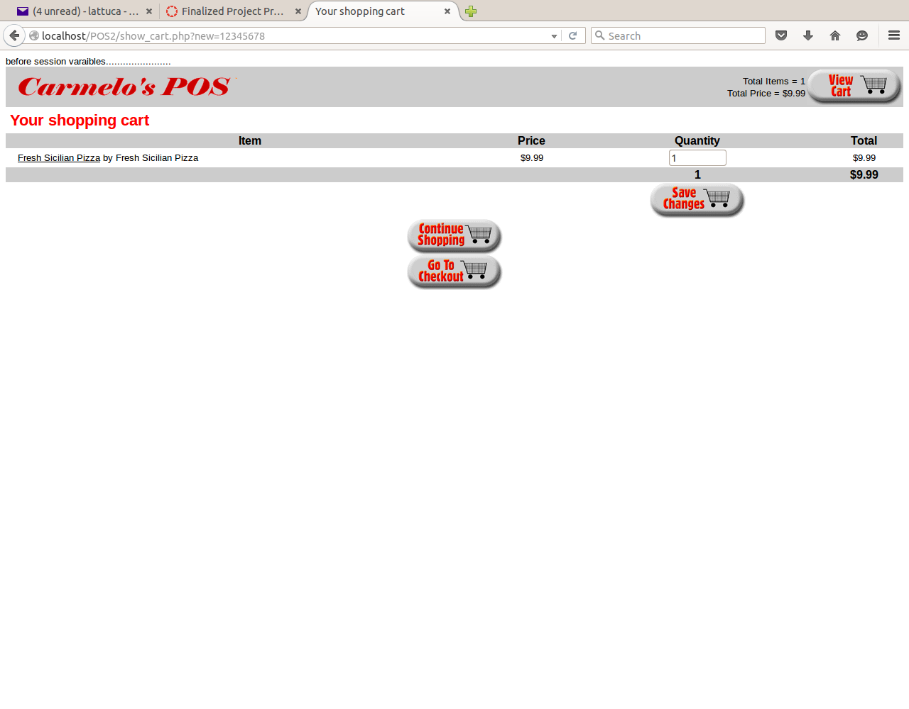

k- Check out and enter customer information

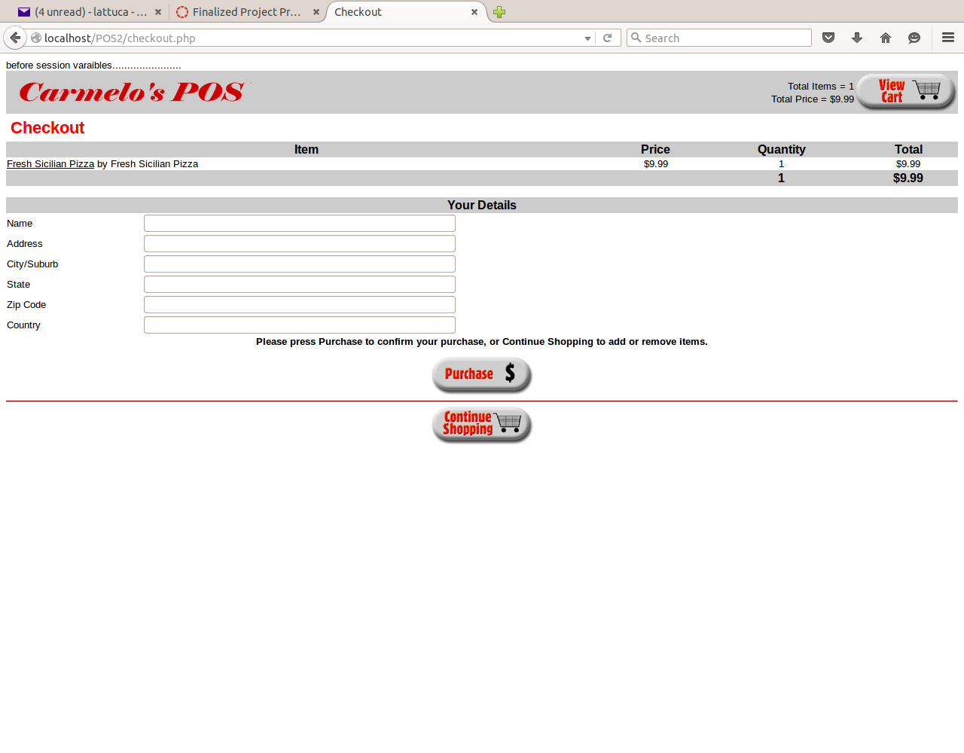

l- Payment

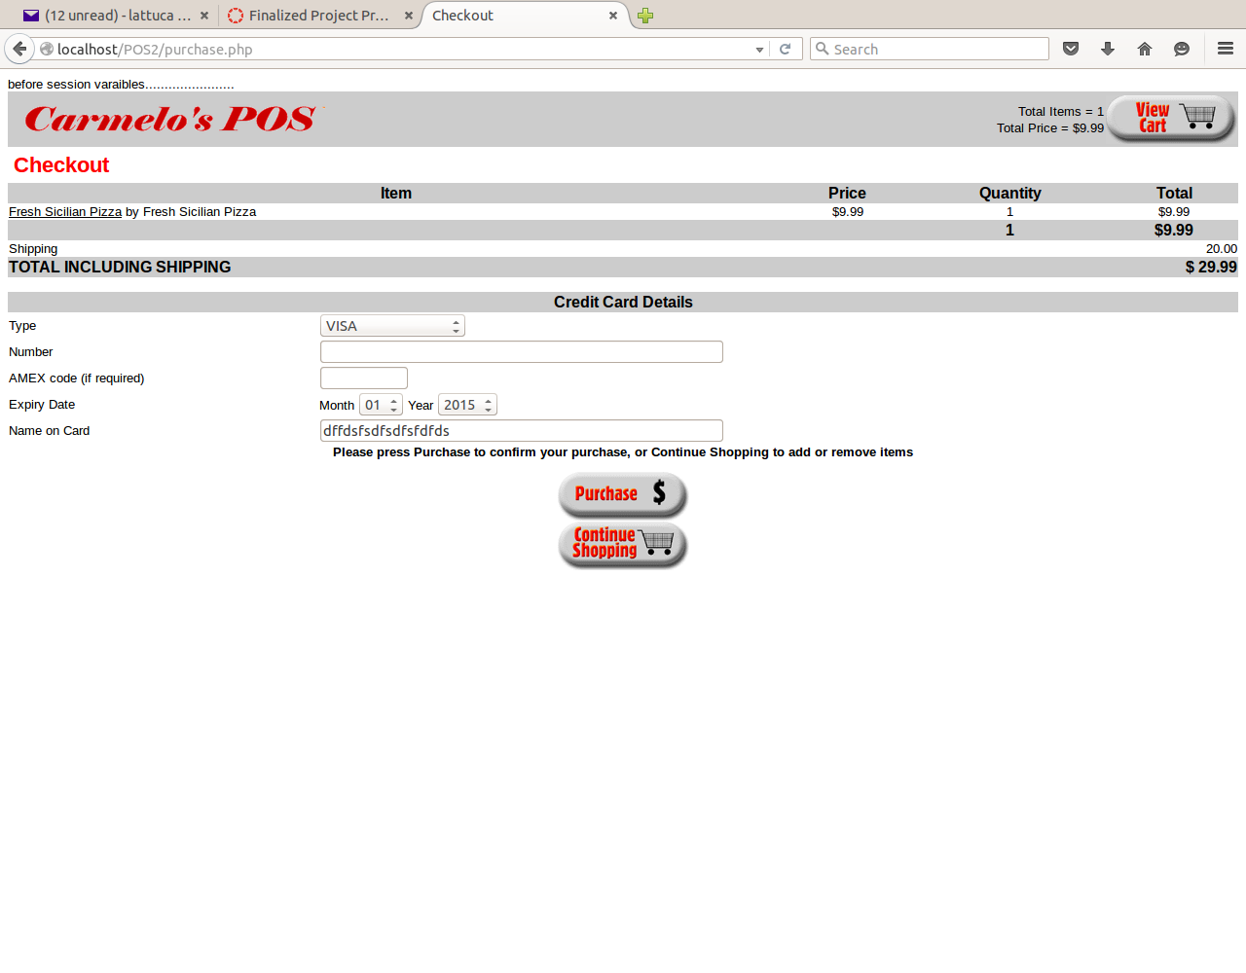

m-Order Complete

